Appendix A1. Mathematical Equations for sLSTM and mLSTM
The sLSTM mechanism is defined by the following equations:
$z_{t}=φ(w_{z}{ x}_{t}+ r_{z}h_{t-1}+ b_{z})$ (A1.1)
$i_{t}=exp(w_{i}{ x}_{t}+ r_{i}h_{t-1}+ b_{i})$ (A1.2)
$f_{t}=exp(w_{f}{ x}_{t}+ r_{f}h_{t-1}+ b_{f})$ (A1.3)
$o_{t}=σ(w_{o}{ x}_{t}+ r_{o}h_{t-1}+ b_{o})$ (A1.4)
$m_{t}=max (\log\left({ f}_{t}\right)+ m_{t-1},\log{{(i}_{t})})$ (A1.5)
$i_{t}^{'}=exp \left(\log\left(i_{t}\right)- m_{t}\right)$ (A1.6)
$f_{t}^{'}=exp \left(\log\left({ f}_{t}\right)+ { m}_{t-1}- m_{t}\right)$ (A1.7)
$c_{t}= f_{t}^{'}*c_{t-1}+ i_{t}^{'}* z_{t}$ (A1.8)
$n_{t}= f_{t}^{'}*n_{t-1}+ i_{t}^{'}$ (A1.9)
$h_{t}= o_{t}({c_{t}}/{n_{t}})$ (A1.10)
where $z_{t}$ denotes the cell input, $i_{t}$,$f_{t}$,$o_{t}$ denote the input, forget, and output gates, respectively. The stabilizer $m_{t}$ is used to compute the stabilized gates ${i_{t}}^{'}$ and ${f_{t}}^{'}$. In addition, $c_{t}$, $n_{t}$ and $h_{t}$ denote the cell state, normalizer state, and hidden state, respectively.
The mLSTM mechanism is defined by the following equations:
$q_{t}=W_{q}{ x}_{t}+ b_{q}$ (A1.11)
$k_{t}=\frac{1}{\sqrt{d}}W_{k}{ x}_{t}+ b_{k}$ (A1.12)
$v_{t}=W_{v}{ x}_{t}+ b_{v}$ (A1.13)
$i_{t}=exp⁡({ w}_{i}{ x}_{t}+ b_{i})$ (A1.14)
$f_{t}=exp⁡({ w}_{f}{ x}_{t}+ b_{f})$ (A1.15)
$o_{t}=σ⁡({ w}_{o}{ x}_{t}+ b_{o})$ (A1.16)
$m_{t}=max (\log\left({ f}_{t}\right)+ m_{t-1},\log{{(i}_{t})})$ (A1.17)
$i_{t}^{'}=exp \left(\log\left(i_{t}\right)- m_{t}\right)$ (A1.18)
$f_{t}^{'}=exp \left(\log\left({ f}_{t}\right)+ { m}_{t-1}- m_{t}\right)$ (A1.19)
$C_{t}=f_{t}^{'}*{ C}_{t-1}+ i_{t}^{'}*v_{t}k_{t}^{T}$ (A1.20)
$n_{t}=f_{t}^{'}*{ n}_{t-1}+ i_{t}^{'}*k_{t}$ (A1.21)
$\tilde{h_{t}}=\frac{C_{t}*q_{t}}{max⁡(\left|{n_{t}}^{┬}q_{t}\right|, 1)}$ (A1.22)
$h_{t}= o_{t}$⊙ $\tilde{h_{t}}$ (A1.23)
where $\tilde{h_{t}}$is the normalized mLSTM readout and $o_{t}$ is the output gate defined in Eq. (A1.16), which modulates the final hidden state $h_{t}$ through elementwise multiplication.

Appendix A2. Parameter Settings of Compared Algorithms
Table A2.1 Parameter settings of compared metaheuristic algorithms.
Year | Algorithm | Parameter
2025 | Fuzzy adaptive arctic tern optimizer (FAATO) | NP = 80, MaxIter = 5,000
2024 | Arctic tern optimizer (ATO) | NP = 80, MaxIter = 5,000
2020 | Jellyfish search (JS) | NP = 80, MaxIter = 5,000
2019 | Adaptive guided differential evolution (AGDE) | NP = 80, MaxIter = 5,000  p-best rate = 0.20  Initial mutation factor memory = 0.50  Initial crossover rate memory = 0.50  Learning rate for adaptive memory = 0.10
2016 | Whale optimization algorithm (WOA) | NP = 80, MaxIter = 5,000  Spiral shape constant = 1  Control parameter α decreases linearly from 2 to 0  Control parameter α₂ decreases linearly from -1 to -2
2014 | Grey wolf optimization (GWO) | NP = 80, MaxIter = 5,000  Control parameter α decreases linearly from 2 to 0
2014 | Linear success-history adaptive differential evolution (LSHADE) | NP = 80  Minimum population size = 4  MaxFE=400,000  Historical memory size = 6  p-best rate = 0.20  Initial mutation factor memory = 0.50  Initial crossover rate memory = 0.50  Population size reduction factor = linear
2014 | Symbiotic organisms search (SOS) | NP = 80, MaxIter = 1,250
2011 | Teaching-learning-based optimization (TLBO) | NP = 80, MaxIter = 2,500
2007 | Artificial bee colony (ABC) | NP = 80, MaxIter = 5,000  Trial limit= round(0.3 x population size x number of dimensions)
1997 | Differential evolution (DE) | NP = 80, MaxIter = 5,000  Scaling factor = 0.8  Crossover rate = 0.5
1995 | Particle swarm optimization (PSO) | NP = 80, MaxIter = 5,000  Inertia weight = 0.5  Cognitive coefficient = 2.05  Social coefficient = 2.05
1975 | Genetic algorithm (GA) | NP = 80, MaxIter = 5,000  Crossover rate = 0.7  Mutation rate = 0.1
Nomenclature for Table A2.1: NP denotes population size, MaxIter denotes the iteration limit used by algorithms with fixed iteration-based loops, and MaxFE denotes the maximum number of objective-function evaluations. A common budget of MaxFE = 400,000 was explicitly enforced for every algorithm. For algorithms requiring different numbers of objective-function evaluations per iteration, the listed MaxIter values differ accordingly, while actual termination was governed by the MaxFE limit. LSHADE used an initial population size of 80, a minimum population size of 4, and linear population-size reduction, and it terminated directly when MaxFE = 400,000 was reached.

Appendix A3. Default Hyperparameters of AI Models
Model | Name of Hyperparameter | Default Value
KNN | n_neighbors | 5
KNN | weights | uniform
KNN | algorithm | auto
NB | priors | None
NB | var_smoothing | 1.00E-09
SVM | C | 1
SVM | kernel | rbf
SVM | gamma | scale
DT | criterion | gini
DT | max_depth | None
DT | min_samples_split | 2
DT | min_samples_leaf | 1
DT | max_features | None
RF | n_estimators | 100
RF | criterion | gini
RF | max_depth | None
RF | min_samples_split | 2
XGBoost | n_estimators | 100
XGBoost | learning_rate | 0.3
XGBoost | max_depth | 6
XGBoost | subsample | 1
XGBoost | colsample_bytree | 1
CatBoost | iterations | 1000
CatBoost | learning_rate | 0.1
CatBoost | depth | 6
CatBoost | l2_leaf_reg | 3
LSTM | units | 128
LSTM | activation | relu
LSTM | final_activation | sigmoid
LSTM | learning_rate | 0.001
LSTM | loss | binary_crossentropy
LSTM | batch_size | 64
LSTM | epochs | 100
GRU | units | 128
GRU | activation | relu
GRU | final_activation | sigmoid
GRU | learning_rate | 0.001
GRU | loss | binary_crossentropy
GRU | batch_size | 64
GRU | epochs | 100
Note: xLSTM hyperparameters are available in the main text in Table 11. The sigmoid and tanh functions presented in Eqs. (20)–(29) describe the generic internal gating operations of the LSTM and GRU cells, whereas the ReLU activation reported in Appendix A3 refers to the activation function applied in the implemented network layer outside the recurrent gating mechanism.

Appendix A4. Confusion Matrices for Scenarios 2, 3 and 4
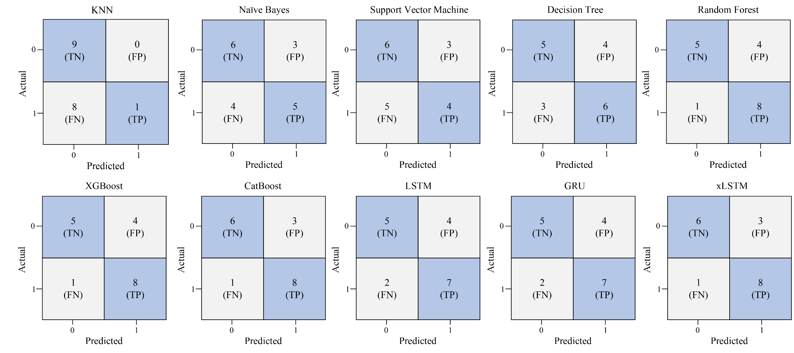
Figure A4.1. Confusion matrix for all baseline models for scenario 2.

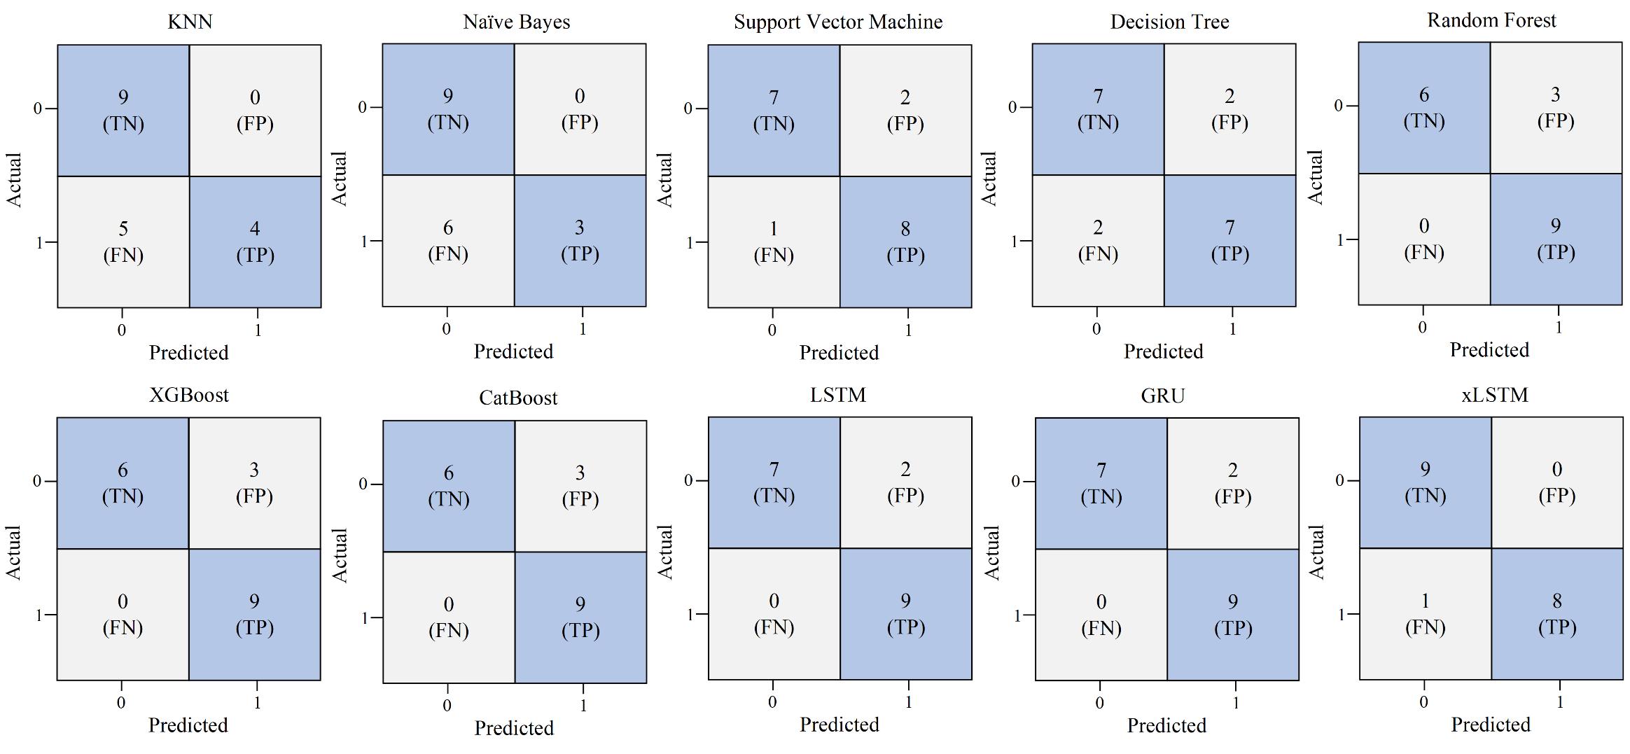
Figure A4.2. Confusion matrix for all baseline models for scenario 3.

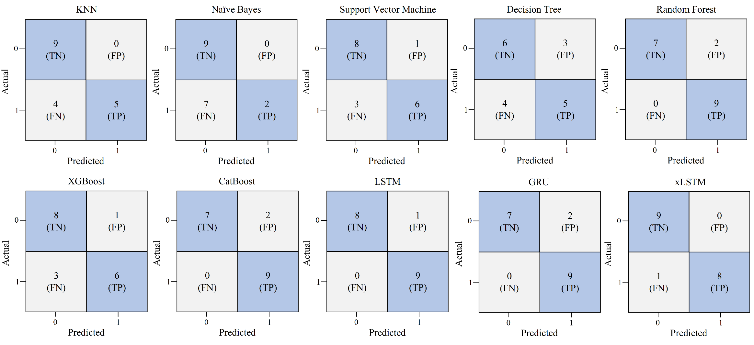
Figure A4.3. Confusion matrix for all baseline models for scenario 4.

Appendix A5. Source Code
The source code developed in this study is available on GitHub at https://github.com/pim-lab/AI-Enhanced-Acoustic-Leak-Detection-for-Sustainable-Urban-Water-Pipeline-Management-DiBE-.

